**Year 2 Semester 1 (2025)**

IT2120 - Probability and Statistics Lab Sheet 09

# Lab Exercise 9 (Statistical Inference)

Before starting the lab sheet, you need to create a folder in your desktop and save all your working inside the folder. Set the working directory to that folder using the following command:



**FacultyofComputing**

setwd("paste the path of the folder")

**Eg:-** setwd("D:\\2025 - Sem 2\\IT2120\\Lab Sessions\\Lab 09")

1. Let’s suppose that a student is interested in estimating how many memes their professors know and love. So they go to class, and every time a professor uses a new meme, they write it down. After a year of classes, the student has recorded the following meme counts, where each count corresponds to a single class they took:

3, 7, 11, 0, 7, 0, 4, 5, 6, 2

Test weather on average, professors know 3 memes at 5% level of significance.

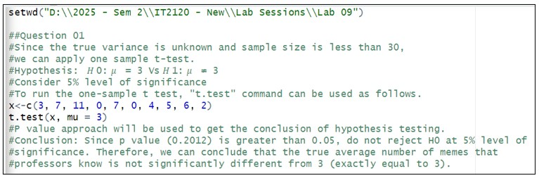

1. Let’s consider the weight of 10 mice in gram:

17.6, 20.6, 22.2, 15.3, 20.9, 21.0, 18.9, 18.9, 18.9, 18.2.

* 1. Test whether the true mean weight of mice is less than 25g at 5% level of significance.

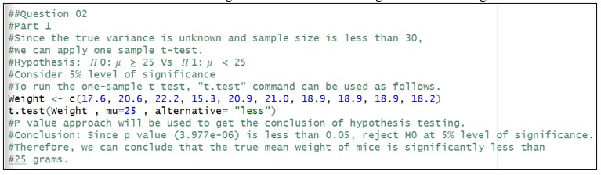

* 1. 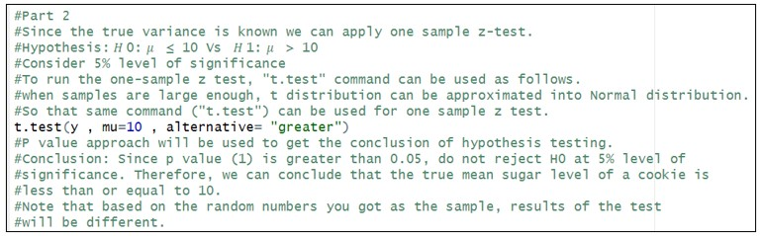Obtain the value of test statistic, p-value and confidence interval out of the test results separately using suitable R codes.

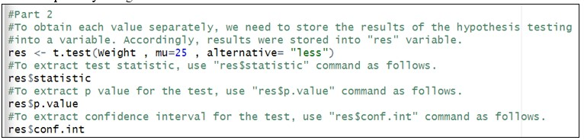

1. The Sugar level of a Cookie follows a normal distribution with mean 9.8 and the standard deviation 0.05. Let’s take a sample of size 30.
   1. Generate 30 random numbers (sugar levels) from the above distribution.

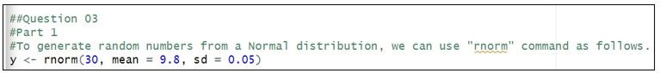

* 1. Test whether the mean sugar level of the Cookies is greater than 10 at 5% level of significance.

## Exercise

**Instructions**: Create a folder in your desktop with your registration number (Eg: ”IT.......”). You need to save the R script file and take screenshots of the command prompt with answers and save it in a word document inside the folder. Save both R script file and word document with your registration number (Eg: ”IT........”). After you finish the exercise, zip the folder and upload the zip file to the submission link.

1. Assume that the time taken to bake a batch of cookies is normally distributed with mean 45 minutes and standard deviation 2 minutes.

1. Generate a random sample of size 25 for the baking time.
2. Test whether the average baking time is less than 46 minutes at a 5% level of significance.

